Group Members:
Christie Chong (cchong@mit.edu), 15.8731
Catherine DiGennaro (cdigenna@mit.edu), 15.873
Aaliya Hussain (ahsn@mit.edu), 15.8731

A4
Our preferred strategy was to slowly expand the firm to avoid the issues associated with exponential growth and start with a higher price that declines over time and maintain a lower overall marketing level to temper demand.
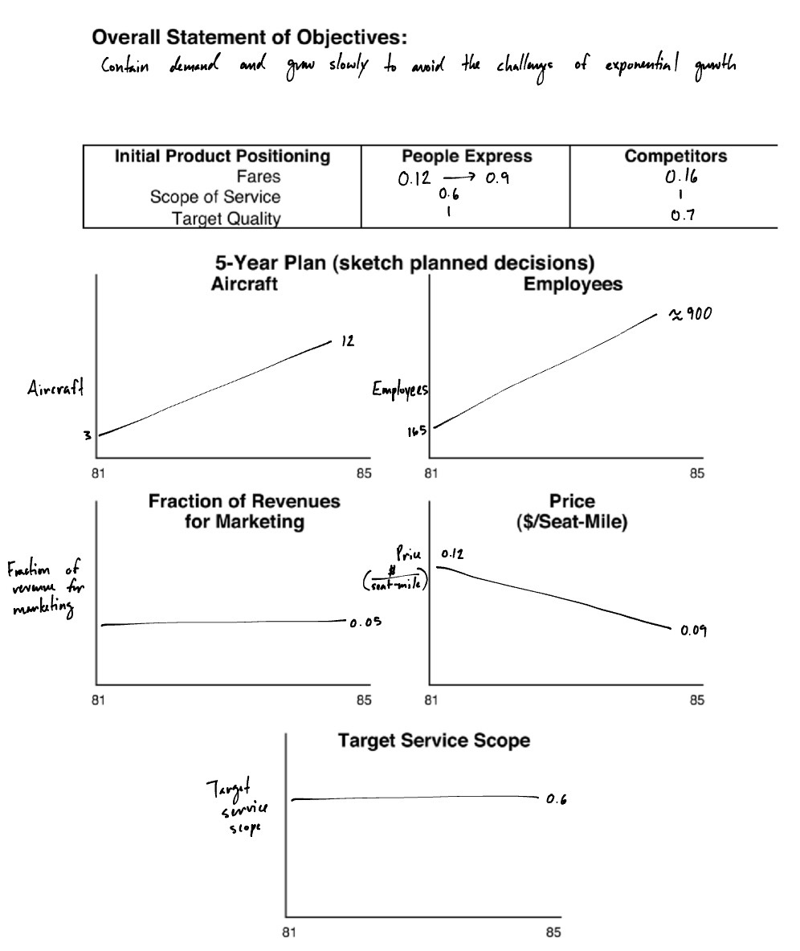

Decisions:
The target scope and marketing remained constant at 0.6 and 0.05, respectively. One aircraft was acquired each year. Each quarter, just enough employees were hired to sustain a slow net increase in the total workforce (i.e., the number of employees hired was just above the turnover rate) and maintain a workweek of 54 to 55 hours; slightly more employees were hired in the quarters with an aircraft acquisition. The fare started at 0.12 and slowly declined to 0.09 over the 10 years.
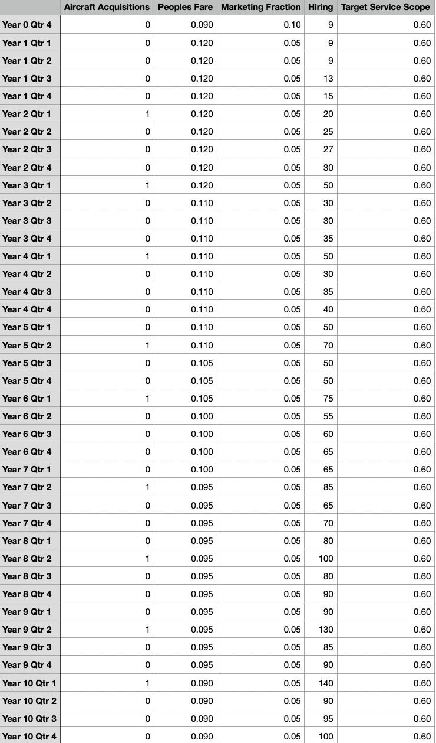

Results:
People Express was still solvent by Y10Q4. The firm’s cumulative profits, stock price, and market value steadily increased. During the early years, customer service declined to 0.7, but did not undergo any further declines in later years. The number of actual flight operations steadily increased but never equaled or outpaced the number of available flight operations. Throughout the 10 years, the load factor and revenue always remained above the breakeven points.

Final (Y10Q4) cumulative net income: $405.0 million
Final (Y10Q4) firm market value: $451.7 million

A5
Important variables and concepts for a model of People Express:
- Service quality
- People Express fare ($/seat-mile)
- Competitor fare ($/seat-mile)
- Number of employees (employees)
- Employee work experience
- Net income ($/year)
- Supply of flights (seat-miles)
- Demand for flights (seat-miles)
- Load factor (dimensionless)

A6
Service Quality from 1981 to 1987:
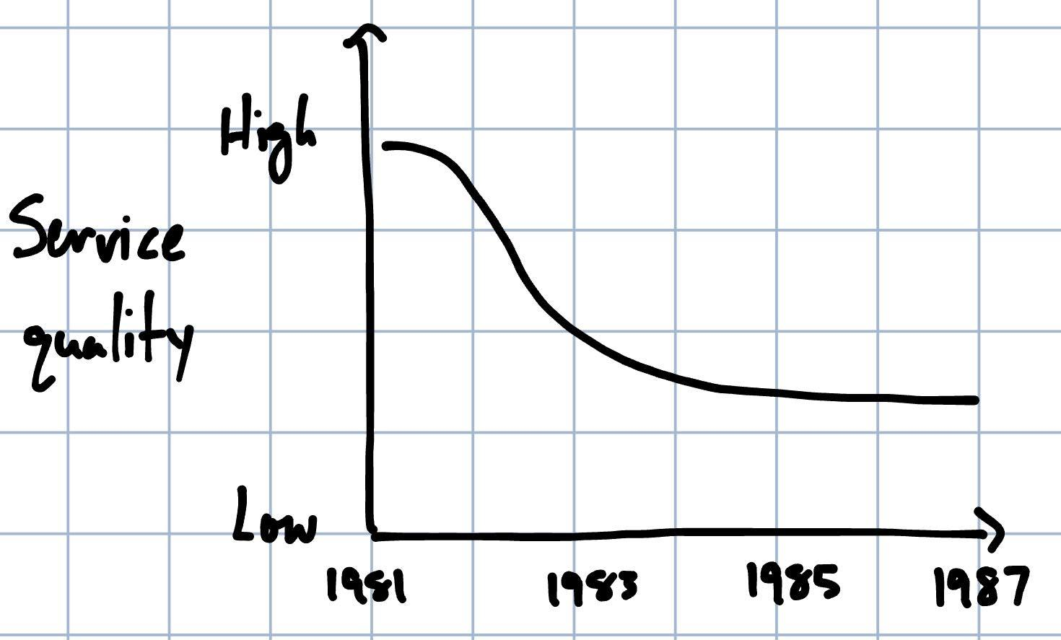

Employee Work Experience from 1981 to 1987:
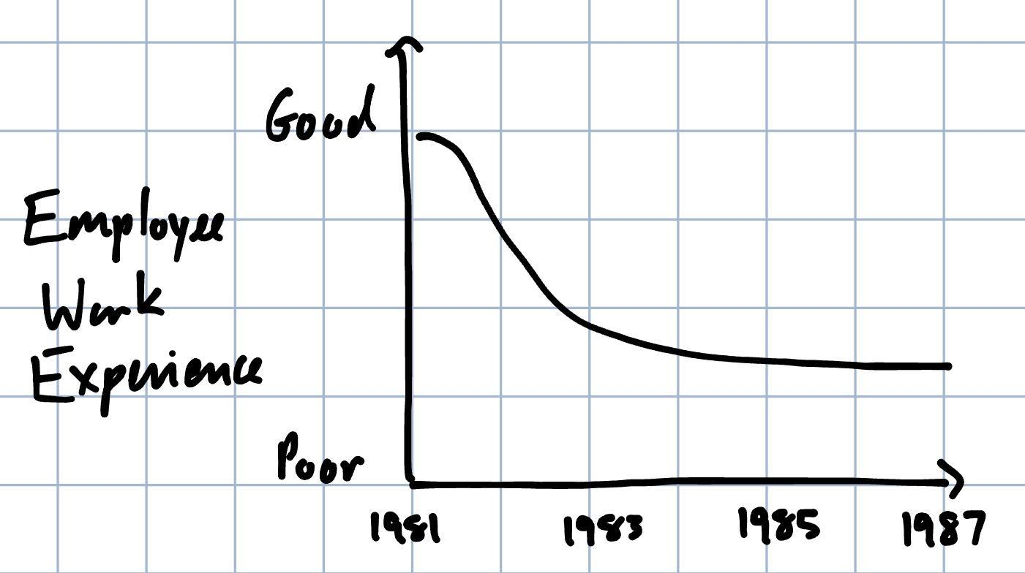
(Note: We infer that declines in employee work experience occurred before the corresponding declines in service quality.)

Net Income ($/year) from 1981 to 1987:
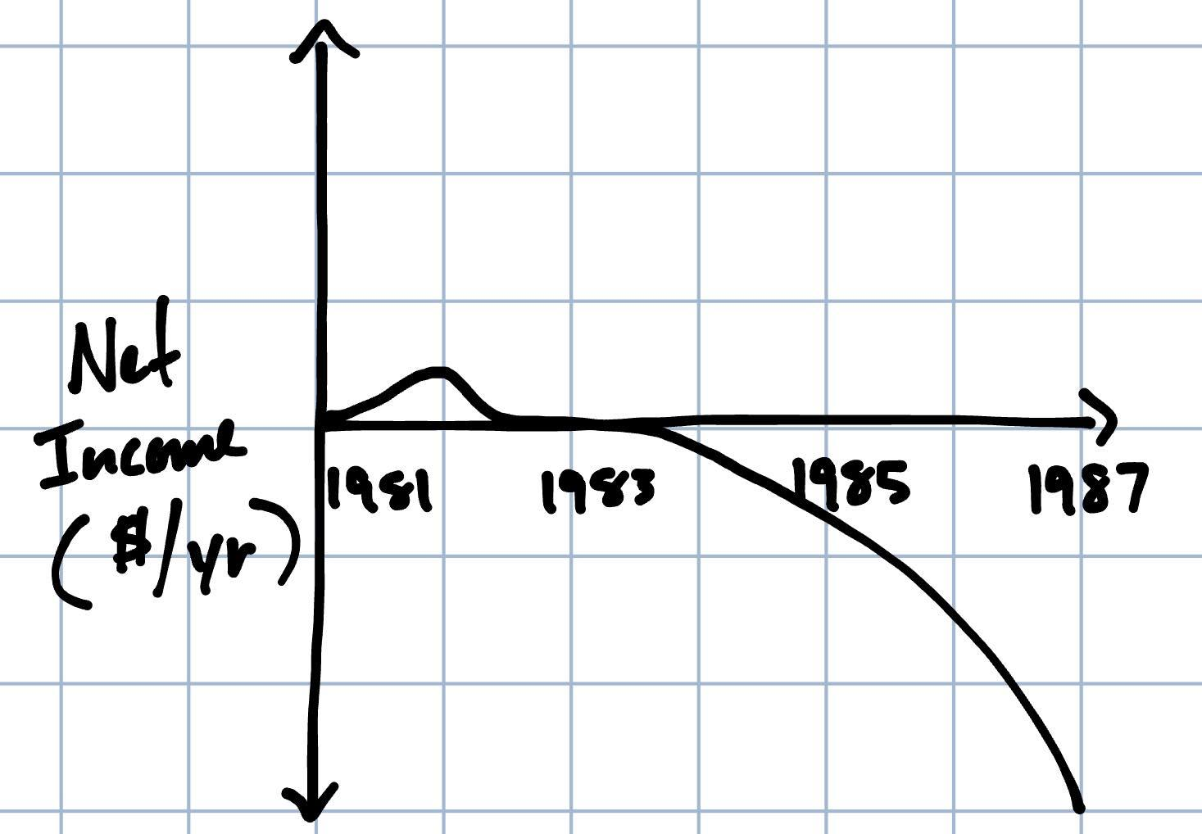

Supply of Flights (seat-miles) and Demand for Flights (seat miles) from 1981 to 1987:
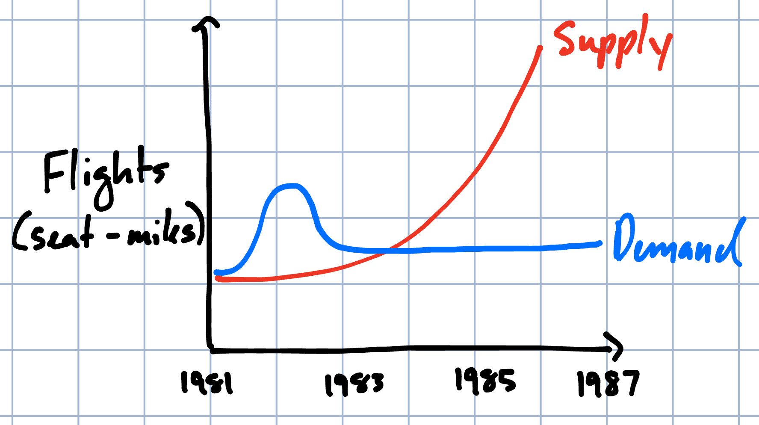

Load Factor (dimensionless) from 1981 to 1987:
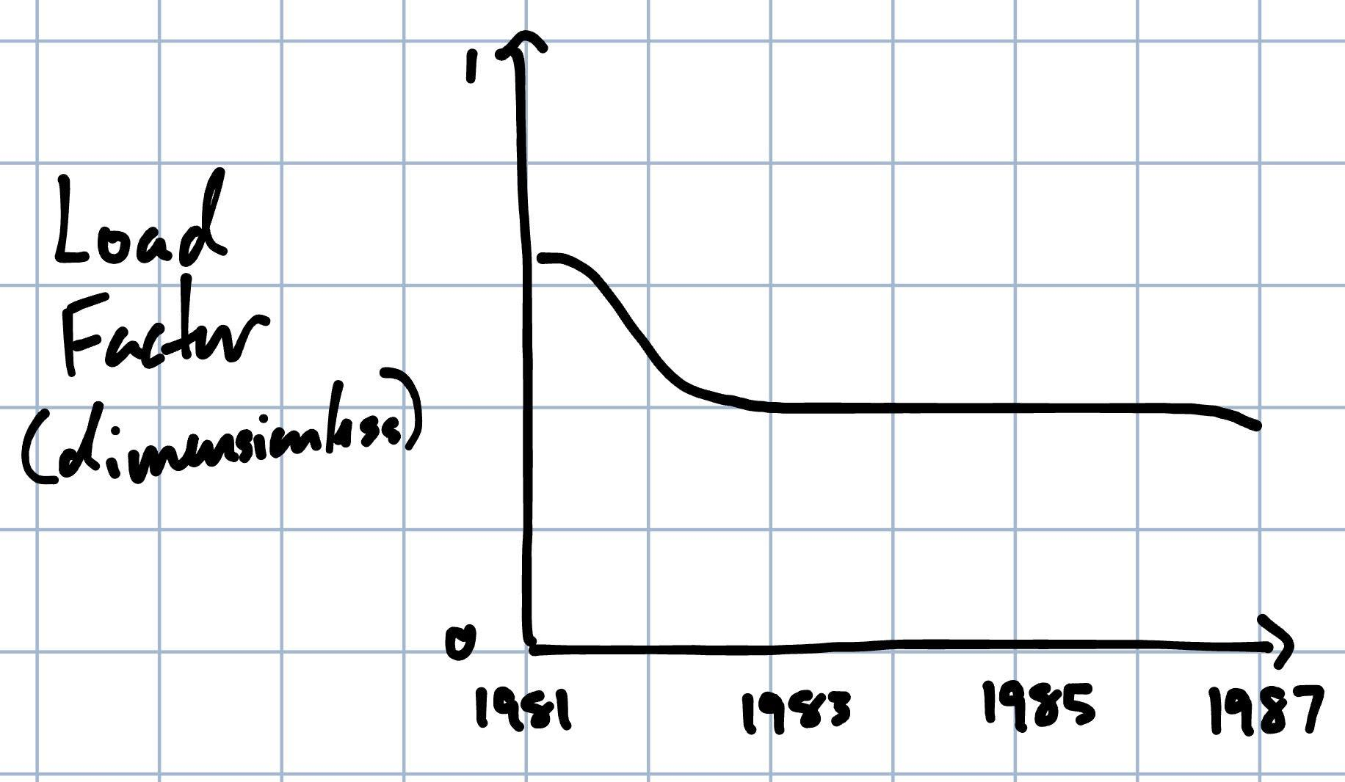

A7

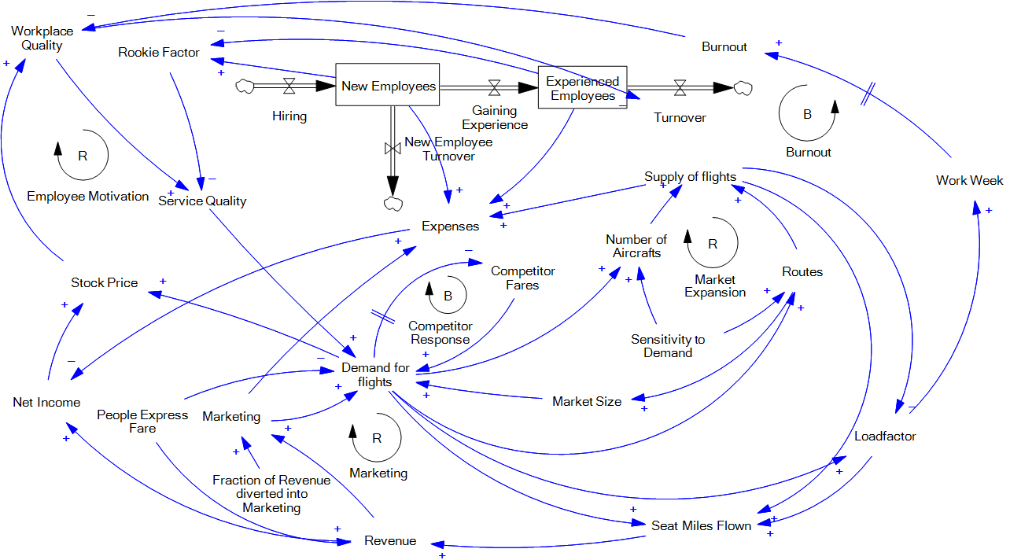

A8
Under Don Burr’s leadership, People Express aimed to offer low fares for flights on routes that were under-utilized by other airlines. Low fares could be achieved by flattening the management structure such that employees worked across multiple functions and taking advantage of economies of scale wherever possible, e.g., by only buying one type of aircraft, Boeing’s 737. Demand for these flights was generated by the low fares and advertisements, with the target market being bus- and car-travelers looking for a faster, no-frills route to their destination. Initially, there was enthusiasm among employees and customers alike for the flight and workplace experience, and People Express grew confident in its ability to handle more demand. In an effort to grow exponentially, the firm purchased new aircraft, hired more employees, and expanded its market size by increasing the number of routes it offered and marketing aggressively. These efforts led to further growth in demand. People Express’ initial success drove up the company’s stock price, and because employees were granted a substantial amount of stock as part of their compensation package, morale and workplace quality improved. In this positive, successful workplace environment, turnover was low; employees who gained experience were motivated to stay. The high ratio of happy, experienced employees led to high-quality customer service, increasing customer demand.

However, the exponential scaling of the firm also created immense organizational challenges that eventually overburdened employees with long working hours and challenges with satisfying the exponentially growing demand from customers. The poor working conditions led to high employee burnout and turnover, forcing People Express to fill their staffing gaps with new employees who were not adequately experienced to handle the challenges of the People Express workplace. The replacement of experienced employees with rookies, along with the challenges of exponential firm expansion, led to declines in service quality. Worsening service quality caused People Express to lose a considerable portion of its demand, which eventually dwindled to the most strongly price-sensitive of their customer segments. The loss of demand reduced People Express’ load factors to levels below the breakeven points, meaning that flights were no longer profitable. People Express employees experienced further burnout from the stresses of serving an increasingly dissatisfied customer base as well as declines in investor confidence in People Express, which directly reduced the compensation received by the employees. These additional stressors led to higher turnover and greater proportions of rookie employees, causing further declines in service quality and demand.

People Express’ demand was further reduced by competitor responses to the high demand that People Express generated in their early years. Observing the attractiveness of People Express’ low fares to customers, competitor firms lowered their fares, with the aid of new yield management technology. These new low fare offerings from competitors diminished the attractiveness of People Express’ fares, causing customers to abandon People Express in favor of competing airlines.

The low load factors and unprofitable flights caused People Express to fall further into debt, eventually leading to the firm’s bankruptcy.

B1
Calculation for the equilibrium number of rookie employees (I_{R}) as a function of the equilibrium number of experienced employees (I_{E}):

At equilibrium, the inflows and outflows into the experienced employee (E) stock are expected equal, which implies:

Assimilation rate (AR) = Experienced quit rate (EQ)

AR = Rookie employees (R) / Assimilation time (t_{a})
EQ = E * Experienced quit fraction (f_{eq})

At equilibrium, R = I_{R} and E = I_{E}

I_{R} / t_{a} = I_{E} * f_{eq}

I_{R} = I_{E} * f_{eq} * t_{a}

B2
Part A
Derivation of expression for P as a function of g:
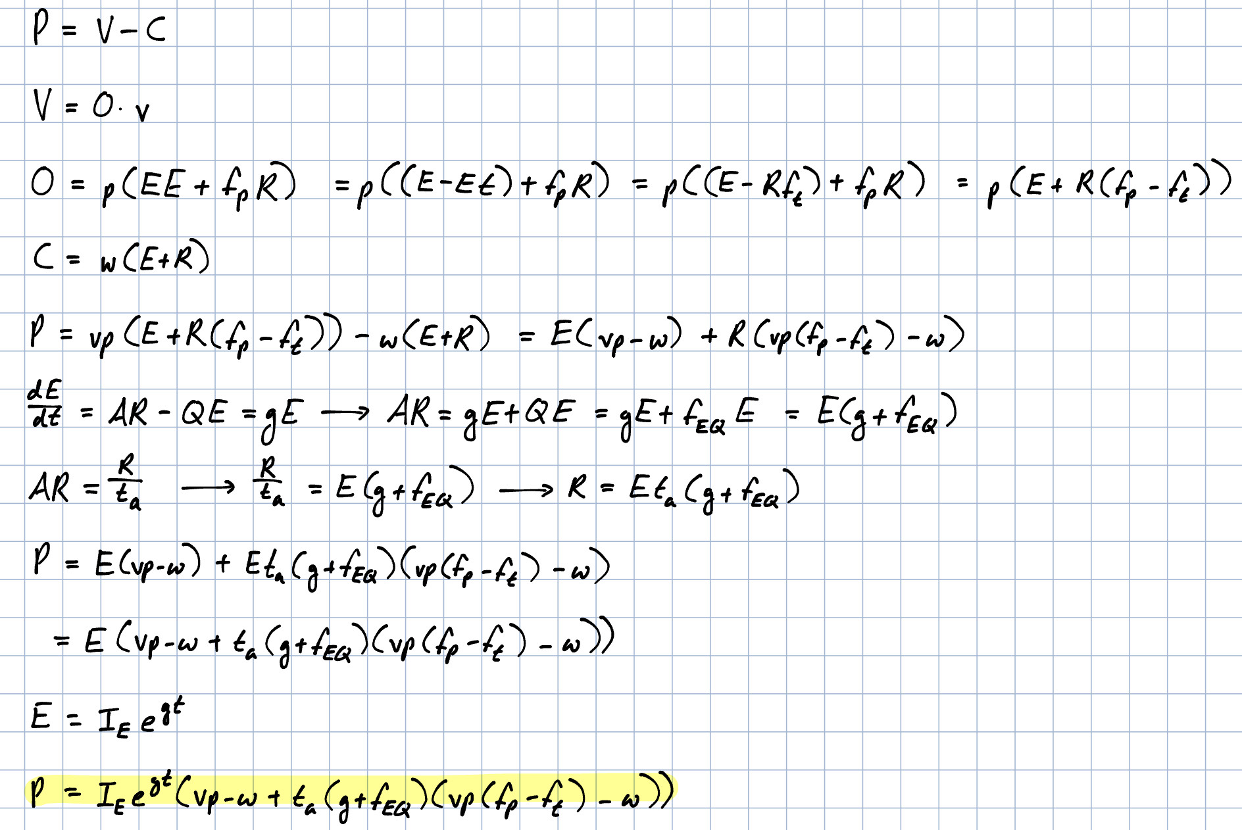

The effects of changing g on P depends on the balance between the benefits and costs of expanding the employee base. Increasing the total number of employees increases the long-term maximum output of the firm (i.e., O), which leads to increased productivity and revenue. However, in the short-term, hiring new employees results in increased costs to the firm because of the relatively low productivity of new employees (i.e., the fact that f_{p} < 1) and the lost productivity of experienced employees who must train the new employees (i.e., the fact that EE < E). The relationship between g and P is thus not strictly monotonic. Low values of g will allow the long-term benefits of expanding the employee base to outweigh the short-term costs, but above a particular value (which would depend on the exact characteristics of the employee stock-flow chain), increasing g would cause the opposite to occur. Mathematically, this balance between long-term benefits and short-term costs is captured by the “t_{a}(vp(f_{p} - f_{t}) - w)” and “vp-w” terms in the expression for P as a function of g. The “vp-w” is positive, representing the long-term productivity benefits, but the “t_{a}(vp(f_{p} - f_{t}) - w)” is negative, representing the short-term costs. If g is large enough, the negative sign of the short-term costs will outweigh the positive sign of the long-term costs because the “t_{a}(vp(f_{p} - f_{t}) - w)” term, unlike the “vp-w” term, is multiplied by an additional factor of g.

Part B
Calculation for the profit-maximizing value of g:
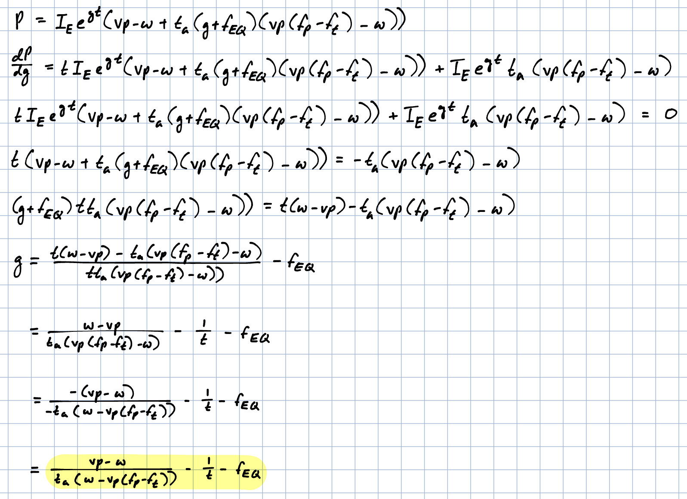

Parameters affecting the profit-maximizing value of g:
- Assimilation time (t_{a}): Increasing t_{a} will decrease the profit-maximizing value of g.
- Experienced employee quit fraction (f_{EQ}): Increasing f_{EQ} will decrease the profit-maximizing value of g.
- Wages (w): Increasing w will decrease the profit-maximizing value of g.
- Dollar value of tasks (v): Increasing v will increase the profit-maximizing value of g.
- Fraction of experienced time required for training (f_{t}): Increasing f_{t} will decrease the profit-maximizing value of g.
- Rookie productivity fraction (f_{p}): Increasing f_{p} will increase the profit-maximizing value of g.

Part C
The optimum growth rate depends on the fraction of experienced employees who are quitting and the relative values of the long-term benefits and short-term costs of hiring new employees:

As this grows and more employees quit, the profit-maximizing growth rate should decrease. This is counterintuitive. As more experienced workers quit, the leaders’ first impulse may be to fill their roles and hedge against additional attrition by increasing growth, but that reaction would divert the remaining experienced employees’ time towards training those new hires, reducing the time available for their tasks (or overloading them, leading to additional burnout and experienced hire quitting). Instead, growth in the total number of employees should decrease by as much as the quit rate increases to avoid this potential death spiral in the number of experienced employees. Reducing the growth in employees in response to an increase in experienced employees leaving may help to address, or at least diagnose, the burnout that caused the increase in the first place.

In the long-term, hiring new employees is generally profitable because building a larger workforce expands the maximum productivity of a firm’s operations. In the short-term, however, hiring new employees incurs costs to the firm because of the low relative productivity of the rookie employees (compared to experienced employees) and the lost productivity of experienced employees who must train the new hires. When determining how many employees to hire, managers should ensure that the hiring rate does not exceed the experienced workforce’s overall capacity to maintain both an adequate level of productivity in the firm’s main operations and train the new hires.

